N.H.P.B. Gunarathna

#272/8,1st Lane, Dewala Rd, Batakattara, Piliyandala.
Phone 0714124004 / 0778063366
e-mail banukagunarathna12@gmail.com
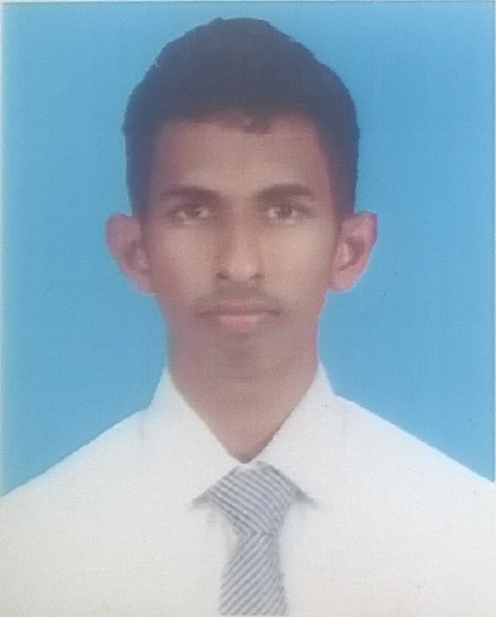
Career Objectives

- To be a successful team member of a dynamic and high growth organization.
- To achieve high standards, be innovative and creative in IT, through open minded and enthusiastic approach to top work, with desire to learn new ideas.

Professional Qualifications

- Higher Diploma in Computer Science – Infortec International Institute.
- 11 months of working experience as a Data Entry Operator at Aitken Spence Cargo.
- Reading for the CCNA exam (Cisco Certified Network Asssociate) – Net Assist International Institiute.
- Reading for BCS PGD level – Infortec International.

Academic Qualifications

- G.C.E. Ordinary Level 2010
English A
Mathematics B
Commerce B
Sinhala B
Buddhism C
Science I C
History C
English Literature C
ICT S

- G.C.E. Advanced Level 2014

Accounting C
Economics S
General English B

Sports and Extra-Curricular Activities

- I have participated in English Day Competitions in 2010 for Stage drama and Won 2nd Place in Western Province.
- I have participated in 2010 All Island Rowing Tournament and Won the 1st Runner Up.
- I was a Team Captain and the keeper under 17 Cricket Team at Panadura Sports Club.
- I was a Member of School Rowing Team.
- I was a senior prefect at Sri Sumana Dhampasala, Piliyandala.
- I was a member at school young Inventors club.
- I was the main organizer at school Commerce Day 2013.
- Playng for Aitken Spence Mercantile crickt team.

Skills

Language and Communication
Fluent in Sinhala and English languages.
Computer Literacy
Familiar with web designing, graphic designing.

Team Work
Experience of working with a team based culture acquired by being a member of the
School projects organizing committee and at Group Projects of the Infortec International.

My Personal Profile

      - Full Name : Nanayakkara Haddagodage Pandula Bhanuka
Gunarathna
- Gender : Male
- Civil Status : Single
- NIC Number : 943100489V
- Date of Birth ` : 5th November 1994
- School attended : Prince Of Wales College
- Contact Details : 0714124004

Non Related Referees
Mr.Chamara Saminda Lakshman
Accountant
AG International (PVT) LTD,
308,Dewala Rd,
Batakattara, Piliyandala.
Mobile-0773666890

Mr.Kavinda Wishwanath
Aircraft Engineer
Sri Lankan Airlines
54/18, Gagabada Rd,
Wawala, Piliyandala.
Mobile-0715463050

I hereby certify that the above facts are true and correct.

